AVIATION SAFETY ACTION PROGRAM: STOCK MARKET EVIDENCE REGARDING PUBLIC POLICY

Saksham Sudershan

1. INTRODUCTION

According to an article by ScienceDaily on a paper by the Massachusetts Institute of Technology (2020), the rate of airline passenger mortality globally was one death per 7.9 million passenger boardings during the period 2008-2017, compared to one death per 2.7 million boardings during the period 1998-2007. Indeed, commercial air travel in the 2020s is safer than it has been at any point in time before, as supported by Fig. 1 which shows a trend of reduced airplane accidents.

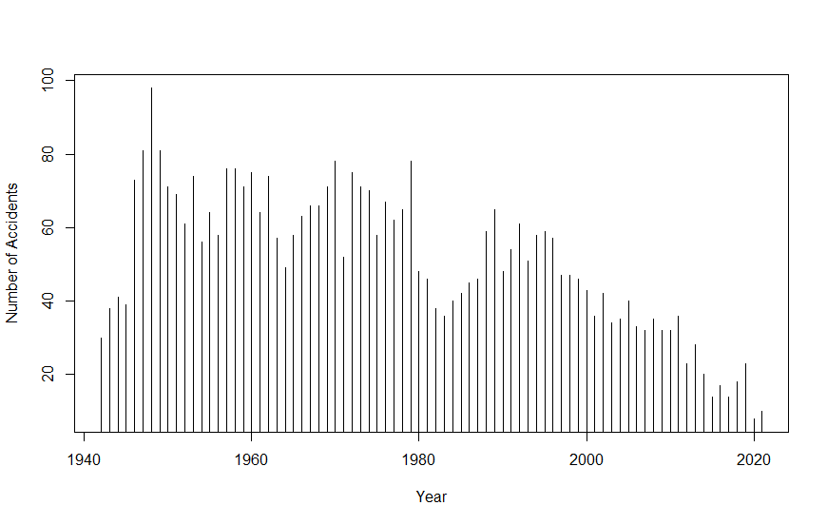

Fig. 1: Frequency of accidents per year. Source: Aviation Safety Network (2021)

The US is also considered to be amongst the regions which house the lowest-risk airlines, with a lower rate of one death per 33.1 million passengers, according to the ScienceDaily article.

In April 2021, The Wall Street Journal published an article titled “The Airline Safety Revolution” (Pasztor, 2021), crediting the policy of the Federal Aviation Administration’s Aviation Safety Action Program (ASAP) introduced in 1997 towards a ‘remarkable’ reduction in the rate of fatal accidents. This program encourages voluntary reporting of safety issues for enforcement-related incentives, and enhances communication between carriers in identifying potential precursors to accidents.

This study examines the financial effect of the ASAP; or if in the aftermath of the ASAP policy, the free market tends to ‘fine’ the airlines involved in the crash more than before 1997. The airline industry can be interesting to see the effects of public policy; this is similar to the investigation carried out by Cavarra, Stover and Allen regarding deregulation.

First, a discussion of past works related to the financial impact of airlines is presented. Next, the event study model to be used in this study is outlined as well as the test sample. The empirical results are presented, with emphasis on comparison to past studies. The conclusions and a discussion are developed further in the final section.

2. FINANCIAL IMPACT OF AIR DISASTERS

Several previous studies examine the impact of air disasters on the stock market. They find negative reactions to air disasters, but importantly do not make the distinction whether the cause of this adverse reaction stems from speculated fines that will be faced by the disaster incurring airline, or if the adverse reaction results from product-safety concerns and an anticipation of decline in future sales of tickets by the airlines.

Cavarra, Stover and Allen in their paper “The Capital Market Effects of Airline Deregulation” (1981) examine whether the deregulation of the airline industry in the US changed the risk perception by the capital markets. They find a definite increase in systematic risk after airline deregulation, however the public policy implications of deregulation are stated to be ‘less clear’. This pre- and post-deregulation study importantly identifies the air travel industry as a benchmark for a field where product safety is of utmost importance, and how studying policies affecting this industry can lead to deep insights.

Don M. Chance and Stephen Ferris (1987) examine how the stock prices of carriers react to air disasters. They find that the carriers incurring the crash and their shareholders lose wealth of about 1.2%. They find a moderately significant correlation between the number of fatalities and the reaction of the stock market. They also tested the effect of the crash on all air carriers, to see the reaction on the industry as a whole, and found that there was a modest reaction on the part of the industry, but this could not be interpreted as significant. As such, the industry-wide reaction is not assigned any ‘economic interpretation’.

Severin Borenstein and Martin Zimmerman (1988) examine the losses incurred by shareholders when a major accident occurs. They try to take into account that airlines carry insurance against many of the costs of a crash. They agree with the previous paper and find that shareholders suffer a statistically significant loss when an airline experiences a crash, but the average loss in equity value is ‘much smaller than the total social costs’ of an accident. This according to Borenstein and Zimmerman reflects how airlines are insured against many of the costs of crashes. They also find that there is very little evidence of a positive or negative effect on the demand for other airlines’ services, meaning the industry as a whole is not affected.

The paper “The Competitive Impact of Air Crashes: Stock Market Evidence” by Bosch, Eckard and Singal (1998) contests previous studies regarding the findings related to the industry-wide effect. According to Bosch, Eckard and Singal, while the shareholders of the crash incurring airline see a decrease in their wealth, there is a ‘switching’ effect whereby airlines that service similar routes to those of the crash incurring airlines see an upswing in their returns and also an industry-wide negative effect of a crash.

The papers discussed here all share the view of flights being a product where safety is of the utmost importance, and all argue that the free market has the ability to enforce safety, by supporting firms which consistently provide safer travel, and so the stock market can assume the role of the regulatory authority.

However, there is an identifiable knowledge that this paper hopes to connect, mainly how effective easing of regulation is; and the extent of its effect on the stock market. By exploring how the ASAP affects stock market reactions, we can see how the role of the stock market changes over time.

3. METHODOLOGY

To measure the economic impact of an event on a firm, financial market data can be used, assuming the markets are rational and efficient. For this paper, each air crash is treated as an event and the market is assumed to be rational and efficient. A list of the air disasters considered is given later, along with a brief discussion.

The estimation period for the event study was taken as 120 days before the crash. However, for four crashes in particular, the estimation window covers a previous crash of the same airline. This would pose a problem as the abnormal returns from the previous crash would be included in the linear model used to estimate the coefficients and predict values. For this reason, the crashes which are highlighted in Table 1, derive the estimate of coefficients from 120 days prior to the first crash.

The event window to analyze abnormal returns is taken to be 10 days, wherein the day of the crash is taken as $t=0$. If the stock market was perfectly efficient, we’d be able to see change in returns at the exact time the news of the crash reached shareholders. However, since there is likely some delay, and some crashes happen later in the day after market close, the abnormal returns are expected on the day after the crash, that is, $t=1$. As air disasters are unexpected and unpredicted, the event window does not contain any days before the crash, as any speculation regarding an air disaster is highly unlikely.

Using data from the estimation window, the Fama-French three factor model is used to predict the values of normal returns, which would be the case if the crash being studied did not happen.

To estimate the coefficients, a linear regression is used.

$$R_{it}-R_{ft}=α_{it}+β_{1}(R_{Mt}-R_{ft})+β_{2}SMB_{t}+β_{3}HML_{t}$$

By comparing this value to the actual returns in the event window, we can find abnormal returns.

$$AR_{t}=R_{t}-E(R_{t})$$

Summing abnormal returns for each day over the sample size gives us the average abnormal return for that day for all the events. We can use this to see how the market in general reacts to receiving news of an air disaster. We can also sum over the 10 days to see the extent of the negative reaction of the stock market to the news of an air disaster. By using this measure, the cumulative average abnormal returns, for the pre-ASAP air crashes and post-ASAP air crashes separately, we can compare them using the individual samples t-test.

To perform an event study and to compare the impact of air crashes before and after the ASAP, two data sets were created. As the ASAP was first introduced in 1997, crashes from the 15 years prior to the introduction are used, that is, crashes from 1982 to 1997 were a part of the first data set, and crashes later than 1997 were a part of the second. 15 air disasters randomly chosen from their respective time periods were chosen as the sample. To build the data sets, stock data from The Center for Research in Security Prices or CRSP was obtained.

Table 1 and 2 list all of the 30 events used in this study, and provide a brief description for each event. Highlighted events which use the estimation window of a different crash of the same airlines are marked with an asterisk.

|  |  |  |  |
| --- | --- | --- | --- |
| **Table 1**  **Pre-1997 Data Set** | | | |
| **Event No.** | **Date** | **Airline** | **Ticker** |
| 1 | 11 January 1983 | United Airlines | UAL |
| 2 | 16 April, 1985 | American Airlines | AMR (Now AAL) |
| 3* | 27 June, 1985 | American Airlines | AMR |
| 4 | 2 August, 1985 | Delta Air Lines | DAL |
| 5 | 9 June, 1987 | Alaska Airlines | ALK |
| 6 | 3 February, 1988 | American Airlines | AMR |
| 7 | 15 April, 1988 | Alaska Airlines | ALK |
| 8* | 21 May, 1988 | American Airlines | AMR |
| 9 | 31 August, 1988 | Delta Air Lines | DAL |
| 10 | 24 February, 1989 | United Airlines | UAL |
| 11* | 19 July, 1989 | United Airlines | UAL |
| 12 | 26 December, 1989 | United Airlines | UAL |
| 13 | 3 March, 1991 | United Airlines | UAL |
| 14 | 14 April, 1993 | American Airlines | AMR |
| 15 | 20 December, 1995 | American Airlines | AMR |

American Airlines merged with US Airways, and formed what is now listed on the stock market as AAL. However, this happened in 2012, and in Table 1, this fact is represented by replacing the AAL ticker by AMR, which was the holding company for American Airlines formed in 1982.

|  |  |  |  |
| --- | --- | --- | --- |
| **Table 2**  **Post-1997 Data Set** | | | |
| **Event No.** | **Date** | **Airline** | **Ticker** |
| 1 | 20 November, 2000 | American Airlines | AMR |
| 2 | 11 September, 2001 | American Airlines | AMR |
| 3 | 11 September, 2001 | United Airlines | UAL |
| 4* | 12 November, 2001 | American Airlines | AMR |
| 5 | 21 September, 2005 | JetBlue Airways | JBLU |
| 6 | 8 December, 2005 | Southwest Airlines | LUV |
| 7 | 22 December, 2009 | American Airlines | AMR |
| 8 | 1 April, 2011 | Southwest Airlines | LUV |
| 9 | 27 March, 2012 | JetBlue Airways | JBLU |
| 10 | 22 July, 2013 | Southwest Airlines | LUV |
| 11 | 9 August, 2014 | JetBlue Airways | JBLU |
| 12 | 5 March, 2015 | Delta Air Lines | DAL |
| 13 | 28 October, 2016 | American Airlines | AAL (previously AMR) |
| 14 | 9 October, 2017 | American Airlines | AAL |
| 15 | 17 April, 2018 | Southwest Airlines | LUV |

4. EMPIRICAL RESULTS

The results obtained for the pre-ASAP period show on average no significant negative effect of the air disasters. This is surprising and in direct contention with results of previous papers. However, looking past the surface it can be seen that some of the events have negative returns related to them. While there is no discernible pattern in which some air disasters are treated harshly by the capital markets, those with a higher number of fatalities seem to cause more negative returns for the accident-incurring airlines.

|  |  |
| --- | --- |
| **Table 3**  **Average Abnormal Returns for Pre-ASAP Period** | |
| **Day ( *t = )*** | **Average Abnormal Returns** |
| 1 | 0.0046930238 |
| 2 | 0.0046498811 |
| 3 | -0.0044959645 |
| 4 | -0.0029223227 |
| 5 | 0.0031144585 |
| 6 | -0.0004503103 |
| 7 | 0.0047707571 |
| 8 | -0.0113811384 |
| 9 | -0.0001532824 |
| 10 | 0.0058708441 |

Table 3 shows the average abnormal returns for all the events in the pre-ASAP period given for each day in the event window. The expected results for day 1 was to be close to average, and a decline further. However, as seen in figure 2, the average abnormal returns seem to move almost at random. There are negative returns on day 3 and day 8.

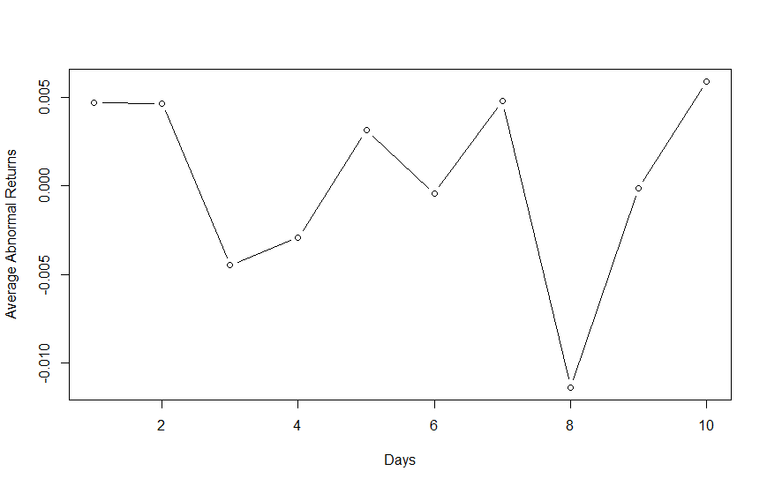

Fig. 2: Average Abnormal Returns Plotted for Each Day in Event Window (pre-ASAP).

The average abnormal returns for the post-ASAP period are closer to what can be rationally expected. There are significant negative returns for the disaster-incurring airline, which seem to go back to pre-disaster levels within the 10-day event window. Table 4 shows the average abnormal returns for each day. It can be seen that there is a much faster response by the market here, in the post-ASAP period. This could possibly be due to news traveling faster with widespread internet use. This time period also contains the September 11 attacks, and could therefore be biased with a more negative view towards air disasters.

|  |  |
| --- | --- |
| **Table 4**  **Average Abnormal Returns for Post-ASAP Period** | |
| **Day ( *t = )*** | **Average Abnormal Returns** |
| 1 | -0.0519559193 |
| 2 | 0.0199354429 |
| 3 | -0.0038066445 |
| 4 | -0.0064383757 |
| 5 | -0.0005998050 |
| 6 | 0.0049763553 |
| 7 | 0.0005121026 |
| 8 | -0.0006167266 |
| 9 | -0.0020470821 |
| 10 | -0.0004302052 |

Figure 4 shows a much easier to understand graph, as compared to figure 3, with large negative returns on the day of the disaster for the disaster-incurring airlines. The returns also seem to go back to normal within the 10 day event window for the post-ASAP period.

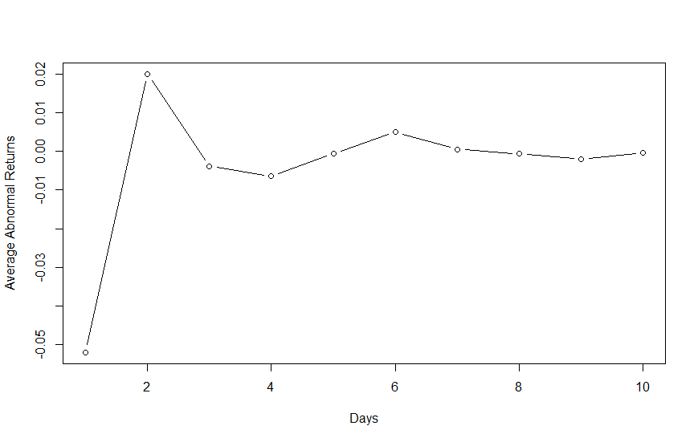

Fig. 3: Average Abnormal Returns Plotted for Each Day in Event Window (post-ASAP).

In order to compare the two, a t-statistic is calculated to compare the samples. However, there is no significant difference between the reactions at the 0.10 significance level, and this difference between the two cumulative average abnormal returns cannot be given an interpretation.

5. CONCLUSION

This is the first study that tackles how the ASAP, and in turn, the use of enforcement-related incentives affects the capital markets and shareholders. However, the inconclusiveness of the test conducted here points to areas which should further be explored to understand public perception of policy regarding regulations or the lack thereof.

For a larger study, it could be possible to take into account all the accidents that have happened in the US in the two time periods. With such a sample, concrete evidence could be produced in support of or against the ASAP.

The randomness seen in figure 3 also points to a knowledge gap in what causes changes in the public perception of accidents. While the number of fatalities seems to be at least somewhat connected, it could also be important to see how shareholders attribute the fault of a disaster to the airlines itself, or another entity, such as the manufacturer.

Finally, there might be significant policy bundling taking place over such a large time period. There have been multiple innovations in the airline industry, while also newer regulations passed. It could be possible to make a difference-in-differences model by taking another country which shares similar technological advancements as the US, but does not have a policy similar to the ASAP. Such studies would help establish support for or even against the power of regulatory bodies in states which have an efficient free market.

**References**

Aviation Safety Network. (2021, November 10). Retrieved from

https://aviation-safety.net/statistics/period/stats.php?cat=A1.

Bosch, J., Eckard, E. W., & Singal, V. (1998). The Competitive Impact of Air Crashes: Stock

Market Evidence. The Journal of Law & Economics, 41(2), 503-519.

Chance, D. M., & Ferris, S. P. (1987). The Effect of Aviation Disasters on the Air Transport

Industry: A Financial Market Perspective. Journal of Transport Economics and Policy, 21(2), 151-165.

FAA. (2002, November 15). Aviation Safety Action Program Document Information. Retrieved

from https://www.faa.gov/regulations_policies/advisory_circulars/index.cfm/go/document.information/documentid/23207

Massachusetts Institute of Technology. (2020, January 24). Commercial air travel is safer than

ever: The rate of passenger fatalities has declined yet again in the last decade, accelerating a long-term trend. ScienceDaily. Retrieved November 9, 2021 from www.sciencedaily.com/releases/2020/01/200124124510.htm.

Pasztor, A. (2021, April 16). The Airline Safety Revolution. The Wall Street

Journal. Archived and retrieved from https://archive.md/rnTR0.